1 Introduction
In contemporary DevOps practices, software reliability relies heavily on packaging consistency and automated lifecycle management. Containerization is an OS-level virtualization method used to deploy and run distributed applications without launching an entire virtual machine (VM) for each application. Multiple isolated user-space instances (containers) share the host OS kernel, offering minimal memory overhead and near-instantaneous startup times.
Docker provides the industry-standard developer tooling to package code, runtimes, system tools, and libraries into portable Docker Images.
However, in real-world distributed architectures, running standalone containers manually introduces vulnerabilities related to high availability, autoscaling, network routing, and automated self-healing. This is where Kubernetes (K8s) operates: it abstracts underlying hardware into an orchestration cluster, managing container scheduling, replicas, rollouts, service discovery, and health checks across computing nodes.
2 Laboratory Objectives
The core technical objectives accomplished in this laboratory experiment are:
- Container Creation: To construct an Nginx-backed web application and assemble a deterministic Dockerfile.
- Image Compilation & Execution: To build, tag, and verify the container image, running it standalone on host port 8080.
- Declarative Manifest Authoring: To author production-ready Kubernetes YAML manifests for Deployment (specifying desired replica states) and Service (NodePort networking).
- Cluster Orchestration: To launch a localized cluster via Minikube and deploy the containerized workload.
- Dynamic Horizontal Scaling: To scale pod instances dynamically from 2 to 4 replicas and evaluate zero-downtime traffic handling.
- Observability & Teardown: To observe pod scheduling, endpoint registration, and cleanly decommission cluster resources.
3 Architecture Diagram & Explanation
The following architectural diagram illustrates the complete workflow: from initial source code and Docker compilation to declarative scheduling in Kubernetes with NodePort routing.
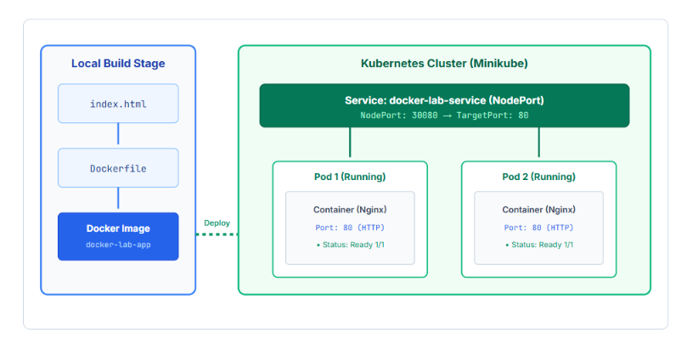
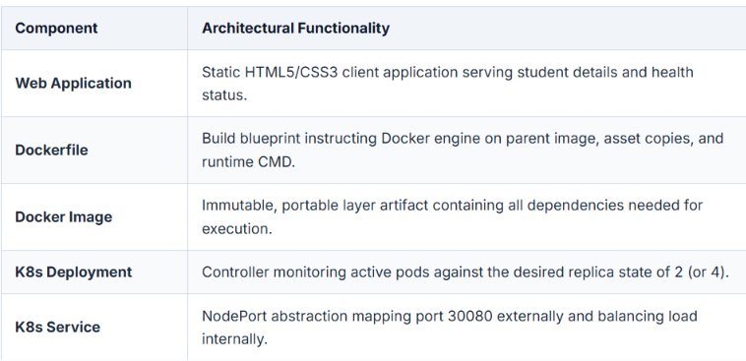
4 Project Folder Structure
A dedicated working directory named lab2-project/ was initialized with all required artifacts:
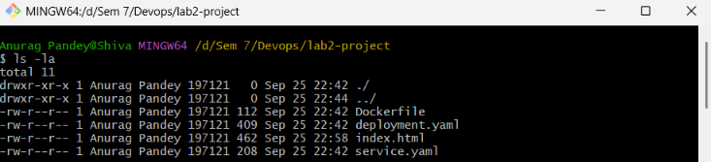
5 HTML Application Code
The web application file index.html was developed to display student details, laboratory credentials, and real-time status:
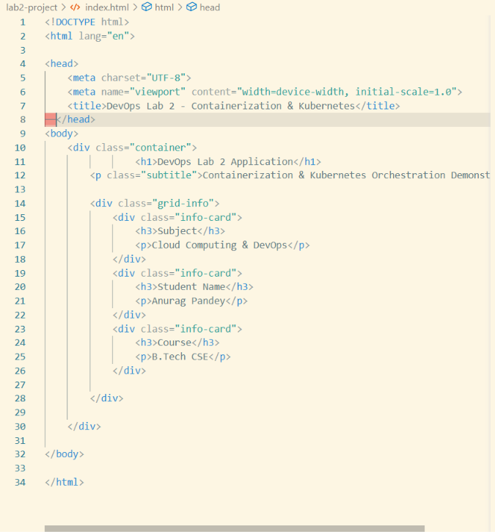

Build Docker Image
The image was assembled using the Docker CLI build subsystem:
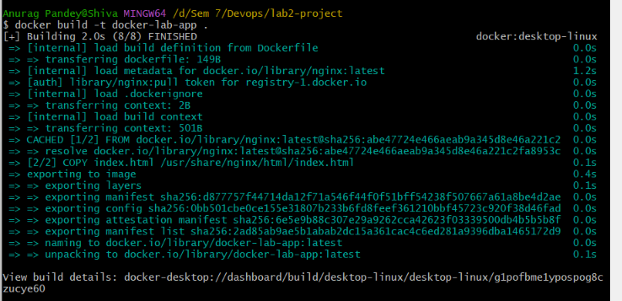
Run Docker Container
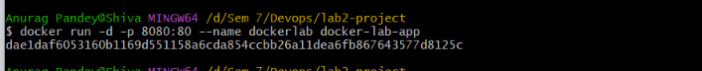
Open Application in Browser
